Double Helix Resources 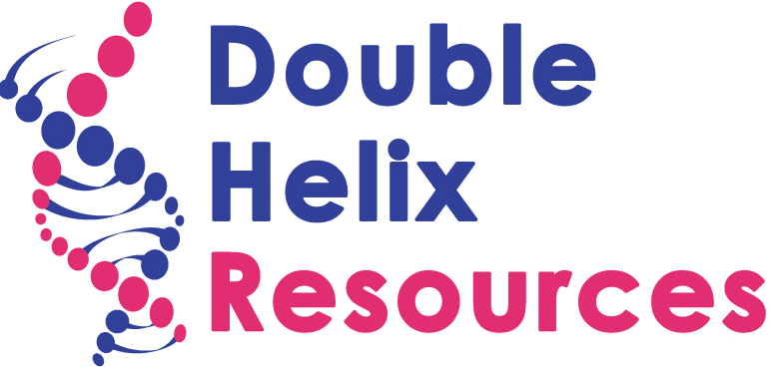
Identity & Belonging in a Fluid Society

“Understanding the past in order to create the future”

Double Helix Resources (DHR) is a company set up in September 2015, with the intention of providing educational and therapeutic consultancy, accredited training and related resources for those supporting troubled and vulnerable children and their families. We develop multi-faceted thinking and training services targeting formal and informal environments. We draw on a range of disciplines including education, psychotherapy, academic research and the creative arts. A network of specialist practitioners and researchers supports the company. They are engaged to work on specific initiatives and projects, as the opportunities arise.
We are infusing these ideas into our collaborations:
Takes @ Home Project, Erasmus +, The role of the family in the acquisition of host country languages
The WHY Project, Erasmus+, Supporting democratic participation of marginalised young people
SIMRA II, AMIF, Supporting the integration of women & girl refugees and migrants
Safe Project, Erasmus +, with University of York, evaluating an Unaccompanied minors project for the British Red Cross.
Citizen 2020, Near Neighbours Fund, with Artification, to develop social interaction between residents; enhance intercultural and inter-religious dialogue; develop social action through creative, sustainable practices and structures for communities to co-create their future.
Delivering community activitist training, John Lyons Fund, with Artification, training on belonging and identity & to schools, youth clubs, families and community groups
Delivering professional mentor training, commissioned by schools, Pupil Referral Units, Youth Services: e.g. City of Lublijana Youth Service, Slovenia
Devising & Delivering professional psychotherapy training: with ‘Terapia’, MA in Psychotherapy; with The Caspari Foundation, MA in Educational Psychotherapy.

Please get in touch: Brian De Lord, Double Helix Resources,
bdelord@double-helix.org.uk

